**DAT 530 Retail Analysis Worksheet**

Using the dashboard provided in Module Two of your Brightspace course, answer the following questions by replacing the bracketed text with your responses. Provide a screenshot for each question to show where your answer came from.

1. How many stores exist for the company?

The company has 104 total stores.

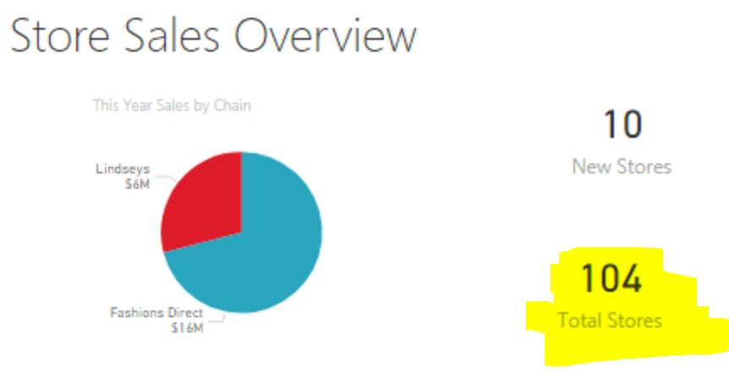

1. How many months are in the visual “Total Sales Variance by FiscalMonth and District Manager”?

There are eight months in the visual from January through August.

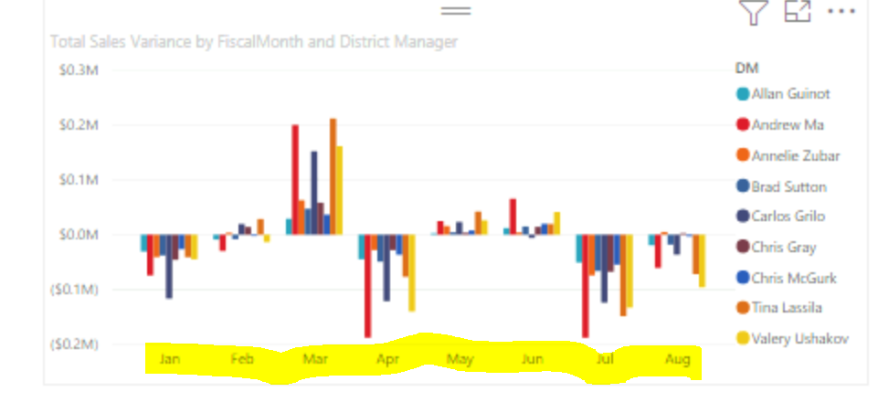

1. From the same chart in question 2, what does Annelie Zubar have for total sales for the month of July?

Annelie Zubar has a total sales variance of -$74,155 for the month of July. The chart “Last Year Sales and This Year Sales by FiscalMonth” shows that Annelie’s total sales were $148,677 for this July and $222,832 for last July.

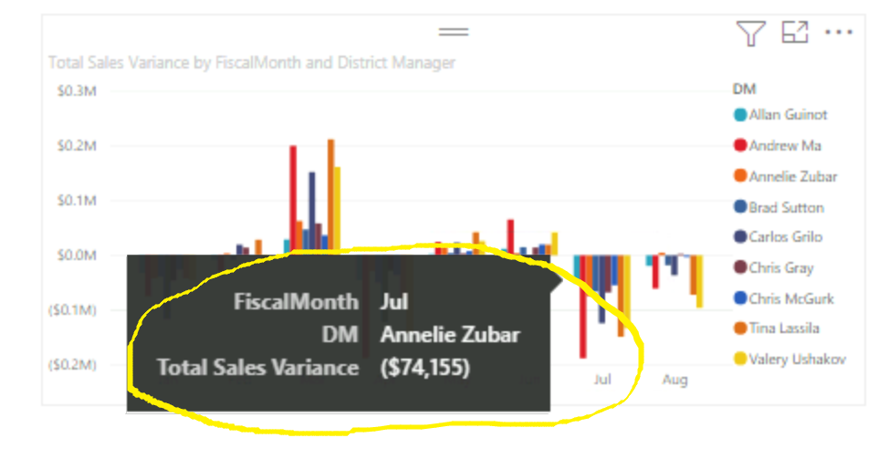

1. Change the tab to “District Monthly Sales.” In “Total Sales Variance %,” what is the average unit sold for shoes?

The average unit price for shoes sold is $13.84.

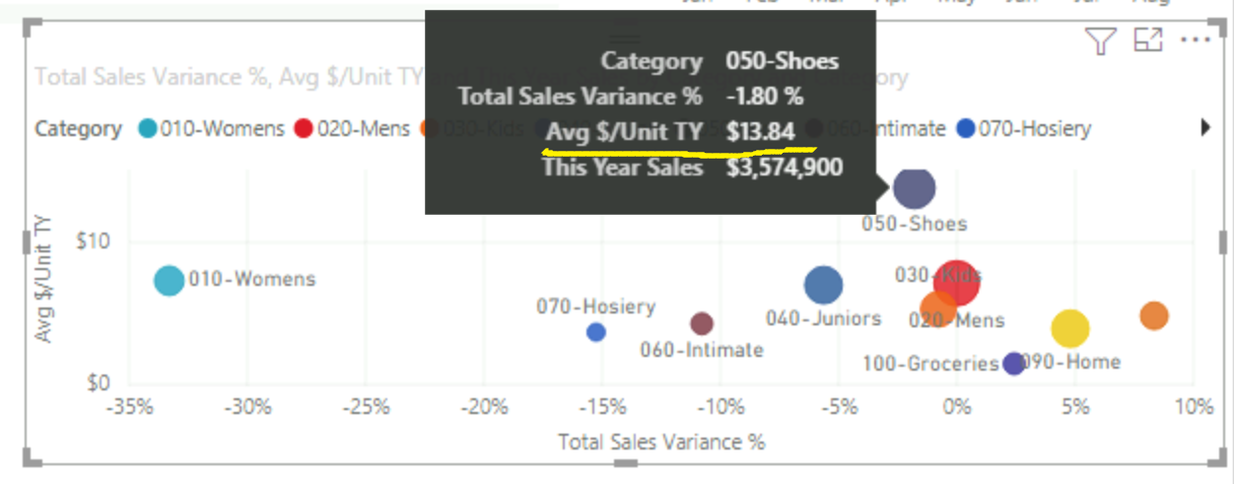

1. Following the same steps as in question 4, what are the total sales for the Juniors category?

The total sales for this year in the Juniors category is $2,930,285.

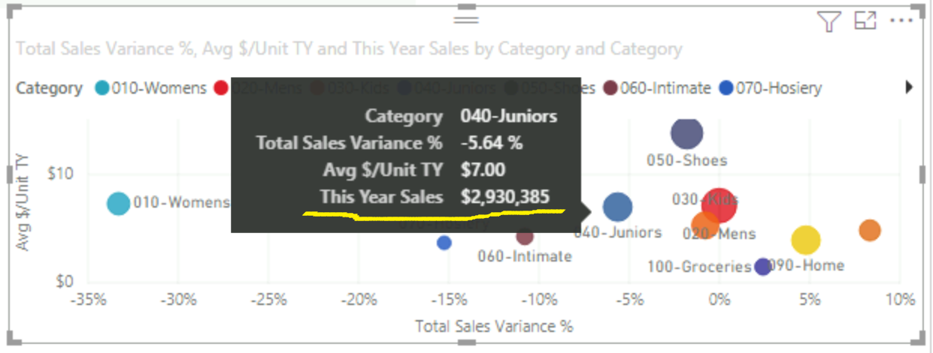

1. Staying on the “District Monthly Sales” tab, what month had the lowest variance percentage?

The month with the lowest variance percentage was July with a drop of about 28%. The month with the variance percentage closest to 0 was February, where this years’ and last years’ sales only differed by 0.14%.

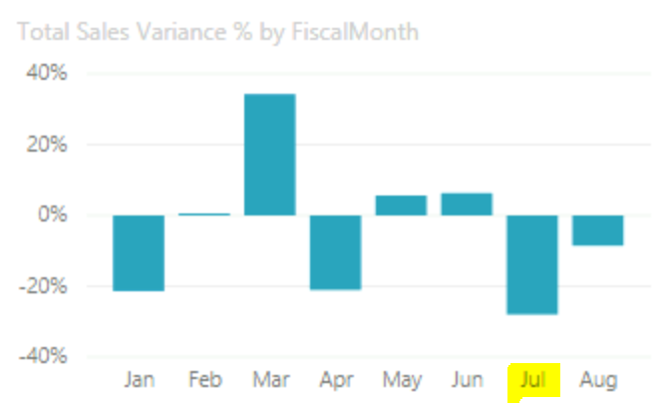

1. Changing the tab to “New Stores” and looking at the open “Store Count” visual, how many new stores opened for Lindsey’s?

Lindsey’s chain opened 4 new stores this year.

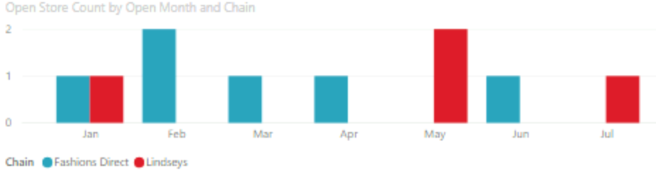

1. Filter the same tab in question 7 by Beckley Fashions Direct. What are the sales per square feet?

Beckley Fashions Direct has a sales per square feet of $15.14.

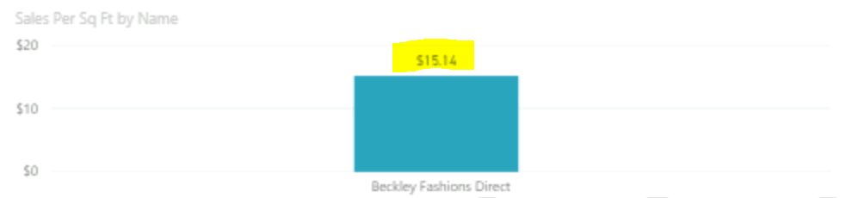

1. Filter to Bel Air Fashions Direct. Based on the line chart, what are the year sales as of May?

Bel Air Fashions Direct had sales that totaled $342,301 as of May.

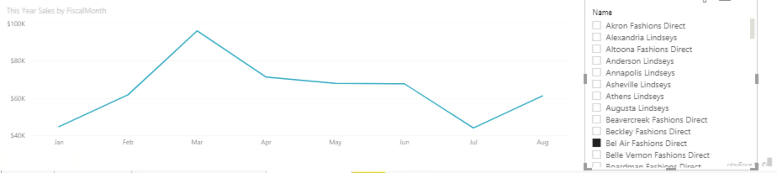

1. Switching back to the “Overview” tab, how many stores opened in Maine?

Zero new stores were opened in Maine.

